**Using Fixed length subnet mask design**

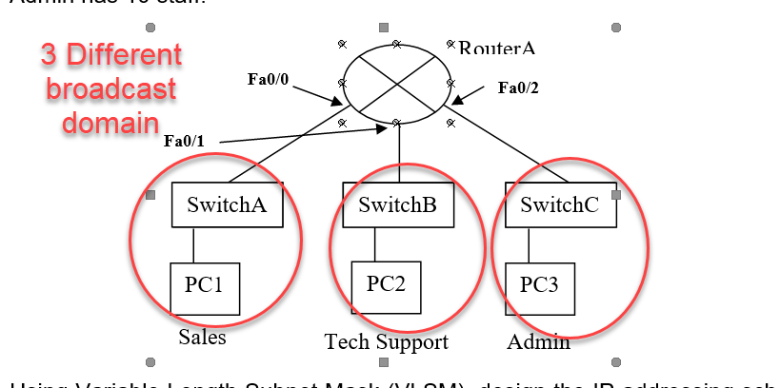

Network address given

= 192.168.1.0 /24

= 192.168.1.0000 0000 -> 192.168.1.0 -> Network address

= 192.168.1.1111 1111 -> 192.168.1.255 -> Broadcast address

= 192.168.1.0000 0001 ~ 192.168.1.1111 1110 -> 192.168.1.1 ~ 192.168.1.254

Sales Dept

No of host given = 50

Min no of host needed = 2 ^ h = 2 ^ 6 = 64

Where h = no of host bits

64 – 2 = 62 max possible hosts

6 host bits needed

Subnetwork address given:

Network bits = 24 + 2 = 26 bits

192.168.1.xx00 0000 / 26

Xx(subnet bits)

00(subnet ID #0) aka 1st subnet

01(subnet ID #1) aka 2nd subnet

10(subnet ID #2) aka 3rd subnet

11(subnet ID #3) aka 4th subnet

**For Sales Dept(Using Subnet ID #0),**

Subnet address : 192.168.1.0000 0000 / 26 -> 192.168.1.0 Always even number

First valid IP : 192.168.1.0000 0001 / 26 -> 192.168.1.1

Last valid IP: 192.168.1.0011 1110 / 26 -> 192.168.1.62 Always even number

Broadcast IP: 192.168.1.0011 1111 / 26 -> 192.168.1.63 Always odd number

Tech support dept

No of host given = 25

Min no of host needed = 2 ^ h = 2 ^ 5 = 32

Where h = no of host bits

32 – 2 = 30 max possible hosts

5 host bits needed

**For Tech Support Dept(Using Subnet ID #1),**

Subnet address : 192.168.1.0100 0000 / 26 -> 192.168.1.64

First valid IP : 192.168.1.0100 0001 / 26 -> 192.168.1.65

Last valid IP: 192.168.1.0111 1110 / 26 -> 192.168.1.126

Broadcast IP: 192.168.1.0111 1111 / 26 -> 192.168.1.127

Admin dept

No of host given = 10

Min no of host needed = 2 ^ h = 2 ^ 4 = 16

Where h = no of host bits

16 – 2 = 14 max possible hosts

4 host bits needed

**For Admin Dept(Using Subnet ID #2),**

Subnet address : 192.168.1.1000 0000 / 26 -> 192.168.1.128

First valid IP : 192.168.1.1000 0001 / 26 -> 192.168.1.129

Last valid IP: 192.168.1.1011 1110 / 26 -> 192.168.1.190

Broadcast IP: 192.168.1.1011 1111 / 26 -> 192.168.1.191